**Template for: FOOP Skills Demo Two - CRAPS**

**SECTION ONE: CLEARLY DOCUMENTED SOURCE CODE**

Algorithm provided to solve problem statement:

1-Start.

2- Import Scanner to get inputs from user (for continuing the game).

3-Create a class with Craps name. (Name of the class is the name of the java file)

4- Declare and initialize public variable of point to hold the point of the game in all methods.

5- Declare and initialize public variable of dices (dice1 and dice 2) to hold random numbers that created in rollDice method.

6- Declare and initialize public variable of total to hold the total of 2 Dice.

7- Declare public variable of keppRolling to hold the second round of the game.

8- Before creating main method, create method rollDice to hold the rolling results of 2 dice with numbers between 1-6, and calculate the total of 2 dice results.

9-Add return command to return total variable.

10- Create FirstRoll method for first round of the game.

11- Do rolling while point is 0, if total was not 2,3,7,11,12 then the point is total of two dice.

12- Create separate function for second roll and keep rolling. ( play method)

13- Do rolling while keepRolling Boolean = true.

13- If keeprolling=true, then call rollDice method result as total. Do rolling while point was not equal total.

14 If total=7, display total and “lost with 7”.

15-If total= point in first round, display total and “Made point, won!”

16- If total was not 7, or point, then display total and no help.

17- Create main method.

18- Declare Choice to hold the answer of player to continue game.

19- Declare and initialize Scanner to receive user inputs.

20- Do call FirstRoll() method and Play() method then show the combination results of methods. While user input be Y or y.

Record of comments to be used in program (please provide four examples):

1- Add return command, because this method is not void.

2- create a method(function) for first round of the game.

3- Create separate function for second roll and keep rolling.

total=rollDice(); //Call rollDice method and store it in total.

**SECTION TWO: PROGRAM FUNCTIONALITY**

Working program & Prudent Use of Print Formatting

Please provide an appropriately cropped and resized screenshot of your **final** program working and insert below:

*Input and Output Screenshot displaying Print Formatting*

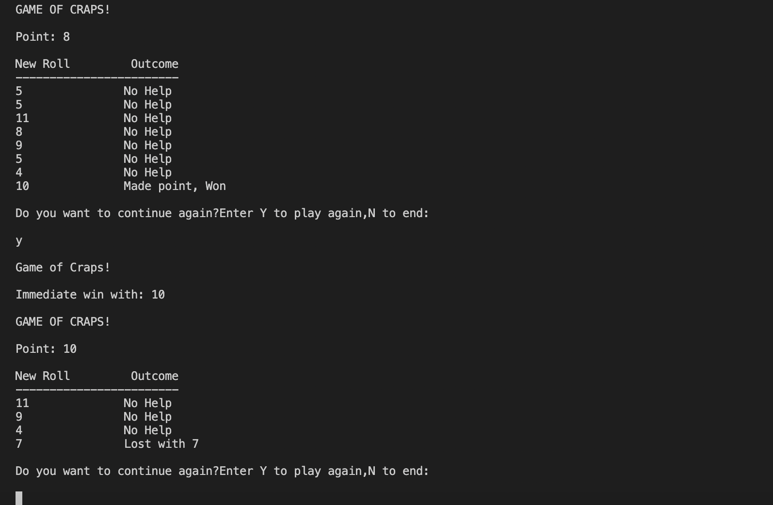

**SECTION THREE: ACCURATE PROGRAMMING (SYNTAX & SEMANTICS)**

Identify all the named identifiers (class, method, fields/variables) in your program in the table below:

|  |  |  |
| --- | --- | --- |
| **Variable Name(s)** | **Purpose** | **Data Type** |
| Craps | It is include of different methods | Public class |
| point | To hold point of the game in methods | Public int |
| dice1 | Hold numbers of dice1 | Public random |
| dice 2 | Hold numbers of dice2 | Public random |
| total | Hold total of two dice | Public int |
| keepRolling | Hold the second round of the game | Public Boolean |
| rollDice | Method for rolling | Int |
| diceValue1 | To hold the value of dice1,between 1-6 | int |
| diceValu2 | To hold the value of dice1,between 1-6 | Int |
| FirstRoll | Method for starting first round of the gam | - |
| Play | Method to continue second round of the gam | - |
| main | Main method to call and execute another methods, and print the results. | String |
| Choice | To hold y/n as user inputs for continuing the game. | Char |
| Scanner console | To get inputs of user | Object |
|  |  |  |

Identify the appropriate working selection statements (if-else) performed in your program below:

|  |  |  |
| --- | --- | --- |
| **Name of Statement** | **Argument** | **Outcome of Argument** |
| total(if) | total==7 | Print total+"\t" +"\tLost with 7" |
| total(else if) | total==point | Print total+"\t" +"\tMade point, Won") |
| else | total ==another values | total+"\t" +"\tNo Help" |
|  |  |  |

Identify the appropriate working control structures (while-loop, for-loop) performed in your program below:

|  |  |  |
| --- | --- | --- |
| **Name of Structure** | **Condition** | **Outcome of Condition** |
| do statement in FirstRoll()-while (point!=total) | switch(total) | Point=total |
| do statement in Play()-while(point!=total) | If( total==7)  If (total==point)  If (total==another values) | Printing the statement of winning and losing. |
| do statement in Play()-  while(keepRolling==true) | do-while(point!=total) | Continue playing |
|  |  |  |

Printout of the final program with comments and line numbers:

import java.util.Random;

import java.util.Scanner;

public class Craps {

public static int point=0;//To hold the pont of the game.

public static Random dice1= new Random();//To hold random number of first dice.

public static Random dice2=new Random();//To hold random number of second dice.

public static int total;

public static boolean keepRolling;

///////////////////////////////////////////////////

//Create a method for rolling.

public static int rollDice()

{ int dice1Value,dice2Vlue;

dice1Value = dice1.nextInt(6)+1;

dice2Vlue = dice2.nextInt(6)+1;

total = dice1Value+dice2Vlue;

//total=7; this is for test of random number generation and test of function.

return total;// Add return command, because this method is not void.

}

///////////////////////////////////////////////////

//create a method(function) for first round of the game.

public static void FirstRoll()

{

do{

total=rollDice();

//Switch used to define loser or winner.

switch(total){

case 2:

case 3:

case 12:

break;

case 7:

case 11:

break;

default:

point=total;

break;

}

}

while(point==0);

}

////////////////////////////////////////////////////

//Create seperate function for second roll and keep rollin.

public static void Play()

{

boolean keepRolling=true;

do{

do{

total=rollDice();

if (total==7){

System.out.println(total+"\t" +"\tLost with 7");

return;//finish of rolling

}

else if(total==point){

System.out.println(total+"\t" +"\tMade point, Won");

return;

}

else{

System.out.println(total+"\t" +"\tNo Help");

}

}while(point!=total);

}while(keepRolling==true);

}

public static void main(String[] args) {

char Choice;//Declare Choice to hold the answer of player to continue game.

Scanner console =new Scanner(System.in);

do{

System.out.println("\nGAME OF CRAPS!\n");

System.out.println("Point: "+point+"\n");

System.out.println("New Roll\t Outcome");

System.out.println("------------------------");

FirstRoll();

Play();

System.out.println

("\nDo you want to continue again?Enter Y to play again,N to end:\n");

Choice= console.next().charAt(0);

System.out.println("\nGame of Craps!");

System.out.println("\nImmediate win with: "+total);

} while((Choice=='y')||(Choice=='Y')||(Choice!='n')&&(Choice!='N'));

System.out.println("End of the craps Game!");

}

}

**SECTION FOUR: SOFTWARE TESTING/ DEBUGGING**

**Evidence of software testing and debugging:**

Provide a screenshot of at least one bug or problem found in your code:

Briefly explain how you overcame this error:

**I forgot to put Play() Method inside of the do-while loop, and the code jus executed calculation of total and point, and did not print another result of rolling of dices. So I call Play() method inside of do-while loop.**

Provide a screenshot of your final programming running using the following input and indicate the output you expect to see before the program is compiled:

|  |  |  |  |
| --- | --- | --- | --- |
| **Input Data** | **Operation** | **Expected Output prior to running program** | **Record actual output from running program here** |
| **Y** | **Char of choice** | **Continue to play** | **Continue to Play** |
| **Y** | **Char of choice** | **Continue to play** | **Continue to play** |
| **N** | **Char of choice** | **Stop playing** | **Stop playing** |
| **n** | **Char of choice** | **Stop playing** | **Stop playing** |

Screenshot(s) using input data:



